**HTML -**  Hypertext Markup Language, it is a building block for webpages

**Simple example:**

structure is **HTML**

Interior paint, designing etc is the work of **CSS**

Electrical connections etc or we can call it functionality is the work of **JAVASCRIPT**

**<HTML lang=”en” dir=”ltr”> …………..</HTML>**

(//html opening and closing tags are used at start and end of web development and everything is inside this tag itself)

**<h1>**…………**</h1>** largest heading tag has 6 levels h1 to h6

**<br>** breaker tag used to break line or send text or element to next line more or like enter in word (no closing tag)

**<hr>** horizontal rule is as word says a horizontal line has many attributes to change color style width etc but now a days CSS is used for styling rather than attributes. Some attributes: align, color, no-shade, size, width. No closing tag.

**<center>……**center aligns the component with in this tag……..**</center>**

**<!--…….-->** used for comment browser will not read anything written within this tag

**<i>………..</i>** italics the component

**<em>……..</em>** gives importance or emphasize the component (basically makes the component italic prefer this over<i>)

**<b>……..</b>** makes component bold

**<strong>………</strong>** gives added importance to content (basically makes content bold prefer <strong> over <b>)

**<ol type=”a/A/1/i/I ” start=”4”>(**starts from no. 4 )(there are other attributes as well like reversed)

**<li>……..</li>** (ol is ordered list used where order of the list matters)

**<li>……..</li>** (li is list item inside li the content of the list is mentioned)

**</ol>**

**<ul> (ul- unordered list)**

**<li>……..</li>**

**</ul>**

**<img src=”c:/photos/Himanshu.jpeg” alt=”Himanshu’s photo”>**

Image tag is used for displaying image in a web page. src tag define the location or source of image and alt tag displays the alternative text in case image is not loaded.

It also has different attributes like align, width etc.

**<a href=”link”>**content**</a>**

**Anchor <a> element with** href attribute is used for creating hyperlinks to webpages, mail, files or location in same page.

Example:

<a href=”<http://www.google.com>”>Google</a>

<a href=”<mailto:abc@gmail.com>”>mailme</a>

**{**<a href=”#section down below”>goto</a>

.

<h2 id=”section down below”> here we go</h2>**}**

**HTML Tables:**

**<table>** (// table tag for creating table)

**<thead>** (//table head for heading row of table)

**<tr>** (//table row for adding row in table)

**<th>………</th>** (//table header for adding data as heading in bold)

**</tr>** (//closing tag of table row)

**</thead>** (//closing tag of table head)

**<tbody>** (//table body for adding content to table; table can work without thead, tbody and tfoot but we should practice to add them for ease of designing and customizing table)

**<tr>** (//table row element)

**<td>………</td>** (//table data element)

**</tr>**

**</tbody>** (//closing tag of table body)

**<tfoot>** (//table footer for adding footer in a table)

**<tr>**

**<td>…………</td>**

**</tr>**

**</tfoot>**

**Table forms:**  forms is an important element in html used for collecting data from user of website

Example:

**<form>**(tag used for making form )

**<lable>……..</lable>** (tag used for adding a lable to element for example lable name can be used before a text type input for collecting name of a user)

**<input type=”**(// types can be text, email, tel, radio, range, file, number, submit etc.)**” name=”**(// here the name of input data is given)**” pattern””>**

(//here functionality of a form element is defined for example collecting text, or email id, or file etc.. )

**<button>** (button tag is used to add a button to the form, can also add button by using input type=

“submit”)**</button>**

**<textarea name=”” rows=”” cols=””></textarea>**

(// text area is used to add a large text area for taking in data/message by the user)

**CSS change Background color:** This is a method called inline css code which is used inside html tags itself**.**

**CSS**  stands for **cascading style sheets**.

**Example:**

<body style=”**background-color:** **blue**;”> (//color name)(// style tag is used inside html element)

**#bb1246** (//hexadecimal codes find codes in: colorhunt.co)

Rgb (255, 255, 255) (//using rgb value)

Rgba (255, 255, 255, 0.5) (// 50% transparent)

Hsl (50, 33%, 25%)

Hsla(50, 33%, 25%, 0.75) (//75% transparent)

**CSS Change Style Using internal code:** This is another method called internal CSS used to change style in web development using CSS**.**

Here we place a <style> opening and closing tags </style> inside head below title and write the name of element in which we want the effect to take place (for example body) and then inside { } brackets we write the style we want to change

**Example:**

**<head>**

**<title> dfgbgwwfqwf</title>**

**<style> body{**

**Background-color: red;**

**} </style>**

**</head>**

**CSS Change style using external code:** This is a method in which we create a external css type file and write all the codes regarding the styling of the webpage, and link this css type file to main page.

**Example:**

CSS file name saved as **style.css in css folder**

**Main code: <Link rel=”stylesheet” href=”css/style.css”>** (// this makes a link of the html file to css file, It is written inside head tags of html.)

**CSS File code:**

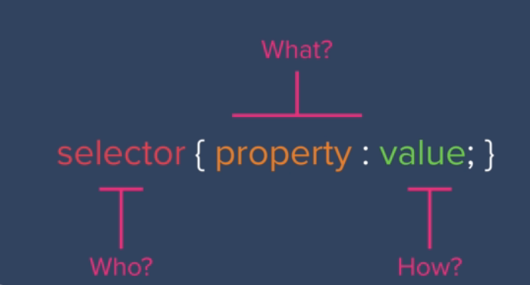**Body{**

**Background-color: red;**

**}**

**H1{**

**color: blue;**

**}**

**Ul{**

**List-style-position: inside;**

**Display: inline-block;**

**}**

**Css selectors**

1. Tag selectors like the h1 tag or img tag or body tag etc.
2. Class selectors like giving a class name to repetitive elements to style them differently example: <**h2 class=” first”**>ABCD</h2>

<h2 class=” second”>ABCD</h2>

Css code///////

.first {

Color: red;

}

.second {

Color: green;

}

1. **Id** selector is similar to class selector only major difference is id’s should be **unique**, same id cannot be repetitively used whereas class can be repeated.

**Example:** <p id=” hello”> hello world </p>

**////////////Css code//////////////**

#hello{

Color: red;

}

1. **Pseudo selectors** it initializes on interaction like mouse hover, button click etc.

**Example:** #hello**:hover**{

Color: blue;

16px=100%=1em

Use rem because px does not change size in accessibility settings and em and percentage multiplies the container sizing

For example:-

If in body font size is 2em

And inside body is h1 and h1 size is set to 4em then h1 will display 8em font

Where as 4rem will display 4em font only no matter the size of font in body element.